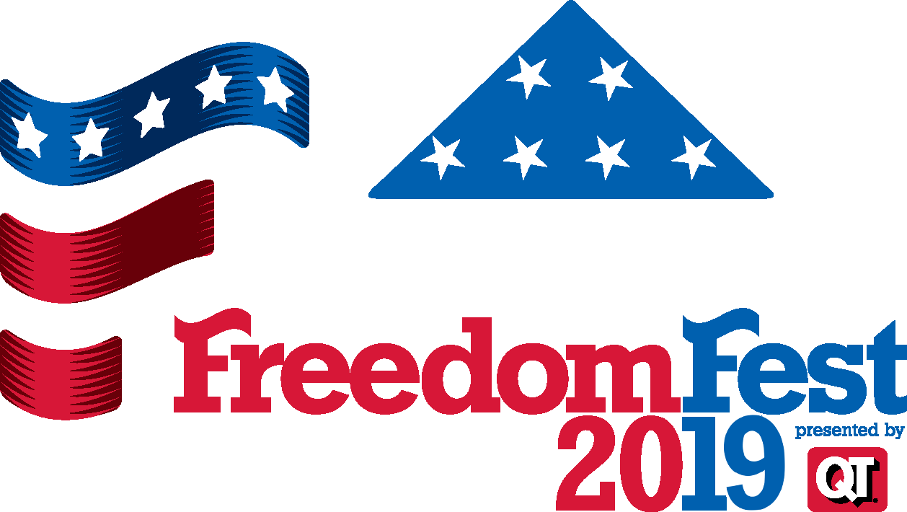
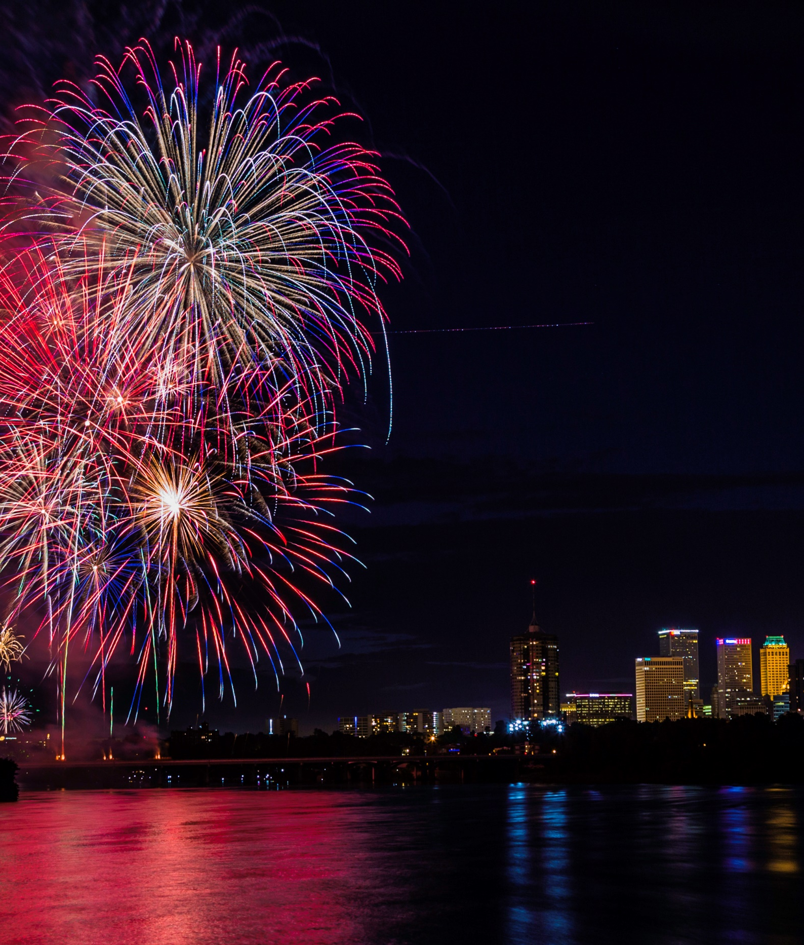
Sponsorship Opportunities
Folds of Honor FreedomFest presented by QuikTrip
Thursday, July 4, 2019

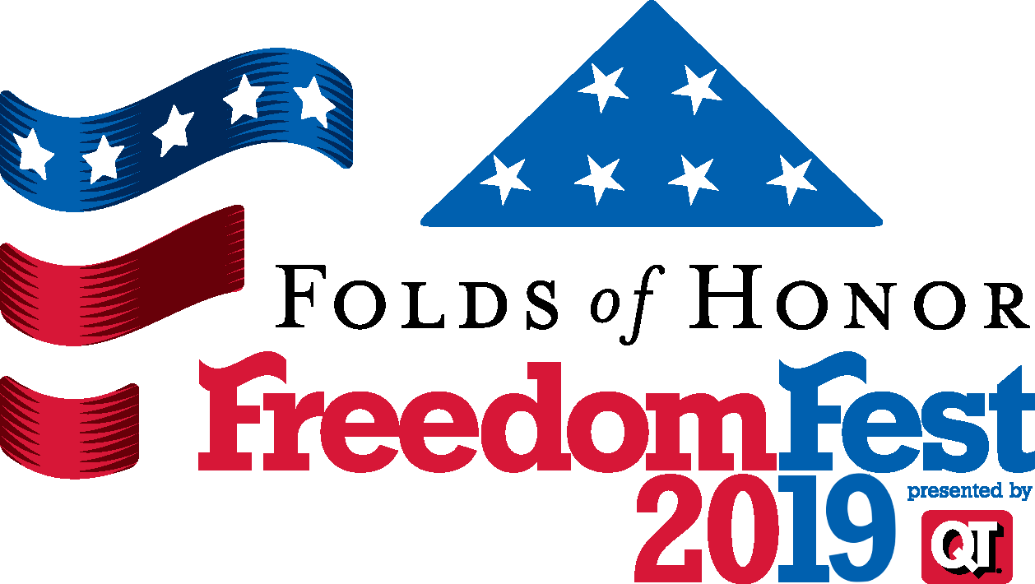
Thanks for your support!
Tulsa’s longest-running and most popular July 4th fireworks display is staged from the 21st Street Bridge over the Arkansas River. More than 80,000 spectators view the display from the river banks, River West Festival Park, and Veterans Park. Enjoy a family-oriented celebration with live entertainment, kids’ activities, and concessions. The size of the festival including fireworks display and free activities offered to the public is determined by the combined support of our sponsors.

Sponsorship Opportunities:
___ Fireworks Grand Finale Presenting: $20,000
___ Main Stage Presenting: $10,000
___ Stars & Stripes VIP Pavilion Presenting: $10,000
___ Kids Zones Presenting: $10,000
___ Patriot Level Sponsor: $5,000
___ Friend of FreedomFest: $2,500
___ Stars & Stripes Pavilion Patron: $1,000

Sponsor Benefits:
Stars & Stripes Pavilion VIP Access at Veterans Park (2 tickets per $500 donated), includes:
- Complimentary Food and Beverages
- Organized Kids’ Activities
- Reserved Fireworks Viewing Area
- Table Topper Name Recognition
- Event Press Release Inclusion
- Mention at Main Entertainment Stages
- Recognition as “Friend of River Parks”
- Riverparks.org Name Recognition
Sponsors ($2,500+) may receive KRMG media mention before & after Fireworks Display simulcast.
Sponsors ($15,000+) receive earned media logo recognition logo, where offered.
Contact River Parks staff for details or to arrange customized sponsor benefits and recognition.
River Parks Foundation is a 501(c)3 not-for-profit organization
To make a sponsor commitment, please return the completed form below:
Contact Name _________________________________ Organization ___________________________

Email: _______________________________________ Phone: __________________________________
Please note your method of payment:
__ Please send an invoice to the Billing Address written below
__ Check is enclosed, payable to River Parks Foundation
__ Please charge credit card as follows: __ VISA __ MasterCard __ American Express __ Discover
Card Number: _______________________________ Name on Card: ____________________________
Expiration Date: ____________________________ 3 or 4 digit security code: _____________________
Authorized Signature: __________________________________________________________________
Billing Address (CC or Invoice):____________________________________________________________
City / State / Zip Code: __________________________________________________________________
River Parks Authority
2424 E. 21st Street, Suite 300, Tulsa, OK 74114
Phone: (918) 596-2001 E-mail: staff@riverparks.org

